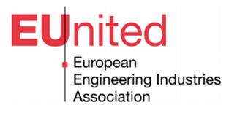
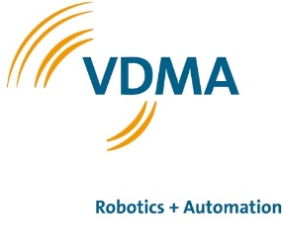

Press Release: One strong platform for robotics in Europe
EUnited Robotics to Join Europe´s Largest
Industry Association VDMA

Brussels, Frankfurt, 27. October 2022 - EUnited Robotics and VDMA Robotics + Automation merge to create one strong platform for the European robotics industry. The members of EUnited Robotics will be represented by VDMA R+A as of January 2023.
“We will combine our resources in one strong European platform to leverage the benefits of automation in Europe. This will boost our efficiency to develop standards for the smart factory of the future, address regulatory issues and promote a human centric future of work,” says Wilfried Eberhardt, Chairman of EUnited Robotics.
13 European countries – 370+ member companies
“VDMA Robotics + Automation unites more than 370 member companies from 13 European countries,” says Patrick Schwarzkopf, Managing Director of VDMA Robotics + Automation. “We look forward to continuing the full range of activities currently carried out by EUnited Robotics, such as the European Robotics Summit, public advocacy, and the Good Work Charter campaign. This is truly a win-win for the European robotics industry.”
New synergies to emerge
Klaus-Dieter Axt, Executive Director of EUnited AISBL, adds:
“The close cooperation between EUnited Robotics and VDMA R+A is already well established and reflected in the large overlap of membership in the two association platforms. With this strategic decision, EUnited Robotics’ members will benefit from new synergies and enjoy the full range of services that the VDMA offers. We will continue the good spirit of cooperation between EUnited and VDMA Robotics + Automation in the future.”

About EUnited AISBL
EUnited AISBL is the European Association that engages with EU policy and decision-makers in their development and optimization of the international regulatory and policy framework for manufacturing. As the voice of machinery and equipment suppliers in Europe, we speak for the companies which make up the core of Europe’s advanced manufacturing capability.
For further information, please visit: www.eu-nited.net
About VDMA Robotics + Automation Association
The VDMA Robotics + Automation Association (VDMA R+A) is a trade association within the umbrella of the VDMA with more than 370 member companies: Suppliers of components and systems from the fields of robotics, integrated assembly solutions and machine vision. The aim of this industry-driven platform is to support robotics and automation through a wide range of activities and services. Key activities include statistical analyses and market surveys, marketing activities, standards development, public relations, trend studies, trade fair policy as well as networking events and conferences. For further information, please visit: https://www.vdma.org/robotics-automation

About VDMA
The VDMA represents more than 3,500 German and European companies of the mechanical engineering industry. The industry stands for innovation, export orientation and medium-sized businesses. The companies employ around four million people in Europe, more than one million of them in Germany. Mechanical and plant engineering represents a European turnover volume of around 800 billion euros. With a net value added of around 270 billion euros, it contributes the highest share of the entire manufacturing sector of the European gross domestic product.
Contacts:
EUnited Robotics
Klaus-Dieter Axt, phone +32 2 706 82 09, e-mail: kd.axt@eu-nited.net
VDMA Robotics + Automation Association
Patrick Schwarzkopf, phone +49 69 66 03-1590, e-mail: patrick.schwarzkopf@vdma.org

